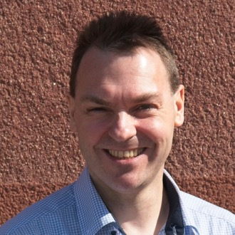 | Torsten Uhlmann  AGYNAMIX® | Senior Full Stack Software Engineer & AI Integration Consultant  Buchenweg 5, 09380 Thalheim, Germany | tuhlmann@agynamix.de | +49 151 12412427 | agynamix.de  linkedin.com/in/torstenuhlmann | github.com/tuhlmann

May 2026
Application as Senior Full Stack Software Engineer / AI Integration Consultant
Dear Hiring Team,
I would like to introduce myself as a senior full stack software engineer and consultant with nearly 30 years of experience building robust, business-critical software systems. Through AGYNAMIX I support companies where reliable engineering, pragmatic architecture, and the ability to understand domain-specific workflows matter more than fashionable technology for its own sake.
My work spans backend systems, modern frontend applications, cloud and DevOps integration, and increasingly applied AI for practical business workflows. Recent projects include AI-assisted PDF invoice analysis in AGYNAMIX Invoicer, using structured extraction, vision models for scanned documents, JSON schema outputs, semantic checks, alternative candidates, and user-in-the-loop review.
I am especially effective in situations where existing systems, business processes, and new technical opportunities need to be brought together carefully. I can join distributed teams hands-on, take technical ownership of focused areas, or support architecture and implementation as an external consultant.
I would be pleased to discuss how my experience in full stack development, integration, automation, and applied AI can contribute to your current goals.
Kind regards,
Torsten Uhlmann
Online resume: agynamix.de/resume

